

Department of Computer Science and Engineering

Course Code & Name | CSA06 – Design and Analysis of Algorithms
Assessment | CO1 – Assessment Tool 1: IT Application-Based Problem Solving – Scalability Audit of an E-Commerce Platform
Course Outcome Assessed | Determine algorithm efficiency using asymptotic notations and mathematical techniques including Master Theorem and substitution method.
Duration | 3 Days
Mode | Individual
Student Reg. No. | 192524483
Student Name | Devadharshini E
Instructions: Answer all parts. Show the basic operation, every step of each derivation and the final asymptotic result, and interpret what each result means for the platform. Assume the platform’s servers execute 10 basic operations per second.

IT APPLICATION-BASED PROBLEM
Scenario – Scalability Audit of “ShopSphere”, an Online Shopping Platform: ShopSphere is a growing e-commerce platform whose product catalogue currently holds n = 100,000 products and is expected to reach n = 1,000,000 within a year. Before the expansion, the CTO has asked you, as the platform’s algorithm engineer, to audit five back-end modules, predict how each will behave as n grows, and recommend which modules must be redesigned. The modules are described below.
Module M1 – Duplicate-Listing Detector: Sellers sometimes upload the same product twice. Every night, the following routine compares every product with every later product.
FOR i ← 0 TO n − 2 DO
FOR j ← i + 1 TO n − 1 DO
IF Product[i].title = Product[j].title AND Product[i].seller = Product[j].seller THEN
MarkDuplicate(j) END IF
END FOR END FOR

Module M2 – API Rate Limiter: The public API audits request windows of doubling size using the routine below. A team member claims that it is Θ(n log n) because the outer loop runs about log n times and the inner loop runs up to n times.
i ← 1
WHILE i < n DO
FOR j ← 0 TO i − 1 DO
Audit(Request[j]) END FOR
i ← i × 2 END WHILE
// basic operation

Module M3 – Product Search: Two versions exist. Version S1 scans the unsorted catalogue sequentially until the product is found. Version S2 searches a sorted product index by

comparing the key with the middle entry and discarding half the index after each comparison; its comparison count satisfies T(n) = T(n/2) + 1, T(1) = 1.
Module M4 – Recommendation Engine: The engine splits the customer–product data into four parts of size n/2 (because of replicated partitions) and merges the partial results in linear time: T(n) = 4T(n/2) + n. A proposed redesign removes the replication, giving T(n) = 2T(n/2) + n.
Module M5 – Sales Analytics Engine: The analytics engine splits the sales data into halves recursively and sorts the records by revenue at every level, giving T(n) = 2T(n/2) + n log n. Separately, profiling shows that the nightly report generator performs f(n) = 3n² + 10n log n + 50 operations.
- Understand the Problem: For each of the five modules, identify the input size and the basic operation that dominates the running time, explain where it occurs, and state how you expect its execution count to grow as n increases. Justify each choice briefly.
- Analyse the Iterative Modules: For M1, derive the exact number of comparisons as a function of n and state the time and space complexity. For M2, derive the exact number of Audit operations, decide whether the team member’s Θ(n log n) claim is correct and give the tight bound. Verify your M2 result for n = 1,024.
- Solve a Recurrence by Substitution: Solve the recurrence for search version S2 using backward substitution, showing every intermediate step, and derive the exact closed form. State the time complexity and the space complexity of both an iterative and a recursive implementation.
- Apply the Master Theorem: For M4, apply the Master Theorem to both the current design and the proposed redesign, clearly identifying a, b, f(n), n^(log_b a) and the case used, and explain what happens to the running time when the data doubles. For M5, determine whether any of the three standard cases applies to T(n) = 2T(n/2) + n log n; if not, derive the complexity using the extended Master Theorem or a recursion tree.
- Analyse Best, Average and Worst Cases: For search versions S1 and S2, identify the input condition that produces the best, average and worst case and give the number of comparisons in each. For S1, derive the average number of comparisons when the probability that the searched product exists is p, and evaluate it for n = 1,000,000 and p = 0.5.
- Prove an Asymptotic Bound: Using the formal definitions, prove that the report generator’s cost f(n) = 3n² + 10n log n + 50 is Θ(n²) by finding constants c , c and n , and show that f(n) is not O(n).
- Scalability Decision: Estimate the number of basic operations and the running time of M1, M2, S2, M4 (both designs) and M5 for n = 1,000,000. Identify the modules that will fail to meet a nightly processing window of 10 minutes, and recommend, with justification, which modules must be redesigned and how.

Rubrics – Application-Based Question

Criteria | Weightage (%) | Level 4 – Exemplary | Level 3 – Proficient | Level 2 – Developing | Level 1 – Beginning
Understanding of Problem Context | 20 | Clearly understands the problem and accurately identifies all requirements | Good understanding with minor gaps | Basic understanding; some requirements unclear | Poor understanding or misinterpretation of the problem
Application of Concepts | 30 | Accurately applies appropriate concepts to solve complex problems | Applies relevant concepts correctly with minor errors | Applies basic concepts with limited accuracy | Fails to apply appropriate concepts
Problem-Solving Approach | 20 | Logical, well-structured, and efficient approach | Mostly logical approach with minor gaps | Basic approach with some inconsistencies | Illogical or unclear approach

Accuracy of Solution | 20 | Completely correct solution with proper justification | Mostly correct with minor errors | Partially correct solution | Incorrect or incomplete solution
Clarity | 10 | Clear, well-organized, and properly explained solution | Understandable with minor clarity issues | Limited clarity and explanation | Poorly presented and difficult to understand

Mark Evaluation:
Criteria | Weightage (%) | Level 4 – Exemplary | Level 3 – Proficient | Level 2 – Developing | Level 1 – Beginning
Understanding of Problem Context | 20
Application of Concepts | 30
Problem-Solving Approach | 20
Accuracy of Solution | 20
Clarity | 10
Total Marks

Code of Conduct
I Devadharshini E-192524483 certify that this submission is my original work and that I have adhered to the guidelines specified for this assessment. I understand that any violation of academic integrity rules will result in disciplinary action.
Signature of the Student: Devadharshini E Date: 11-10-2026

(a) Understand the Problem
Shop Sphere is an online shopping platform whose product catalogue is expected to grow from 100,000 products to 1,000,000 products. The purpose of this scalability audit is to study the efficiency of its backend modules and identify algorithms that need redesign.
The input size n represents the number of items processed by an algorithm. The basic operation is the main operation that determines the running time.
Module | Basic Operation | Expected Time Complexity
M1 – Duplicate-Listing Detector | Product comparison | Θ(n²)
M2 – API Rate Limiter | Audit operation | Θ(n)
M3 S1 – Linear Search | Key comparison | Θ(n)
M3 S2 – Binary Search | Middle-element comparison | Θ(log n)
M4 – Current Recommendation Engine | Recursive computation and merging | Θ(n²)
M4 – Redesigned Recommendation Engine | Recursive computation and merging | Θ(n log n)
M5 – Sales Analytics Engine | Recursive sorting and merging | Θ(n log² n)
Nightly Report Generator | Arithmetic operations | Θ(n²)
The analysis shows that quadratic-time algorithms become expensive as the input size increases. Linear and logarithmic algorithms generally scale better. Therefore, algorithm efficiency must be considered before expanding the platform.
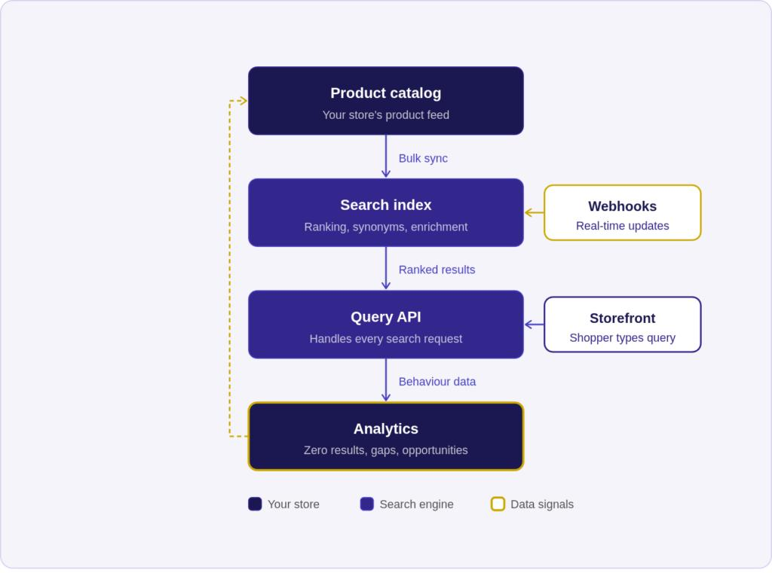
(b) Analyse the Iterative Modules
M1 – Duplicate-Listing Detector
The algorithm compares every product with all the products that appear after it. The number of comparisons is:
C(n) = (n − 1) + (n − 2) + ... + 2 + 1
Using the sum formula,
C(n) = n(n − 1) / 2
C(n) = (n² − n) / 2
Therefore, the exact number of comparisons is n(n − 1)/2.
For n = 1,000,000,
C(n) = 1,000,000 × 999,999 / 2
C(n) = 499,999,500,000 comparisons.
Time Complexity: Θ(n²)
Auxiliary Space Complexity: O(1), excluding the input catalogue and storage for detected duplicates.
Interpretation: The existing algorithm requires nearly 500 billion comparisons for one million products. Hence, it is unsuitable for large catalogues.
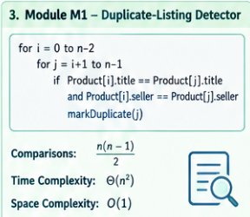
M2 – API Rate Limiter
The value of i doubles in every iteration.
The sequence of audit operations is:
1 + 2 + 4 + 8 + ... + 2ᵏ
Using the geometric-series formula,
A(n) = 2ᵏ⁺¹ − 1
where k = floor(log₂(n − 1)).
Therefore,
A(n) = 2^(floor(log₂(n − 1)) + 1) − 1.
For n = 1,024,
A(n) = 1 + 2 + 4 + ... + 512
A(n) = 2¹⁰ − 1
A(n) = 1,023 audit operations.
The team member's claim of Θ(n log n) is incorrect because the inner loop performs a geometrically increasing number of operations.
Time Complexity: Θ(n)
Auxiliary Space Complexity: O(1)
Interpretation: The algorithm is linear-time, although its execution time still depends on the server's processing capacity.
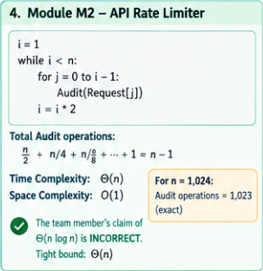
(c) Solve the Recurrence by Backward Substitution
The recurrence for binary search is:
T(n) = T(n/2) + 1, with T(1) = 1.
Step 1:
T(n) = T(n/2) + 1
Step 2:
T(n) = T(n/4) + 2
Step 3:
T(n) = T(n/8) + 3
After k steps,
T(n) = T(n/2ᵏ) + k
The recursion stops when n/2ᵏ = 1.
Therefore,
n = 2ᵏ
Taking logarithms,
k = log₂ n
Substituting this value,
T(n) = T(1) + log₂ n
Since T(1) = 1,
T(n) = log₂ n + 1.
Thus, the time complexity is Θ(log n).
Space Complexity:
- Iterative binary search: O(1).
- Recursive binary search: O(log n), due to the recursion stack.
Interpretation: Binary search reduces the search space by half after every comparison. It is highly efficient for a sorted product catalogue.
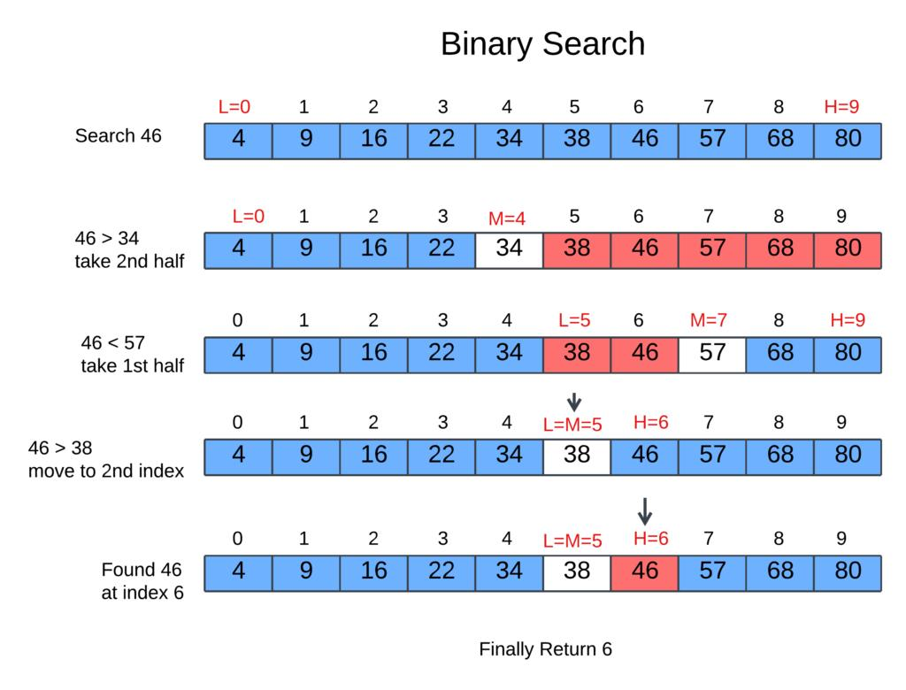
(d) Apply the Master Theorem
The general recurrence is:
T(n) = aT(n/b) + f(n)
M4 – Current Recommendation Engine
Given:
T(n) = 4T(n/2) + n
Here, a = 4, b = 2 and f(n) = n.
Calculate:
n^(log_b a) = n^(log₂ 4) = n²
Since f(n) = n grows more slowly than n², Master Theorem Case 1 applies.
Therefore,
T(n) = Θ(n²).
When the input doubles, the dominant quadratic work increases approximately four times.
M4 – Proposed Redesign
Given:
T(n) = 2T(n/2) + n
Here, a = 2, b = 2 and f(n) = n.
Calculate:
n^(log_b a) = n^(log₂ 2) = n
Since f(n) = Θ(n), Master Theorem Case 2 applies.
Therefore,
T(n) = Θ(n log n).
When the input doubles, the dominant work increases by approximately a factor of two for large n.
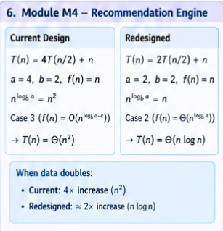
M5 – Sales Analytics Engine
Given:
T(n) = 2T(n/2) + n log n
Here, a = 2, b = 2 and f(n) = n log n.
Calculate:
n^(log_b a) = n^(log₂ 2) = n
The additional logarithmic factor requires the extended Master Theorem.
Using the extended Case 2,
T(n) = Θ(n log² n).
Interpretation: The redesigned M4 is more efficient than the current design. M5 also requires optimization because its running time grows faster than n log n.
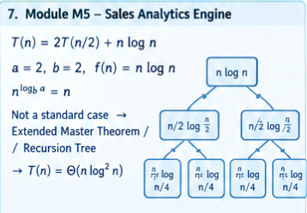
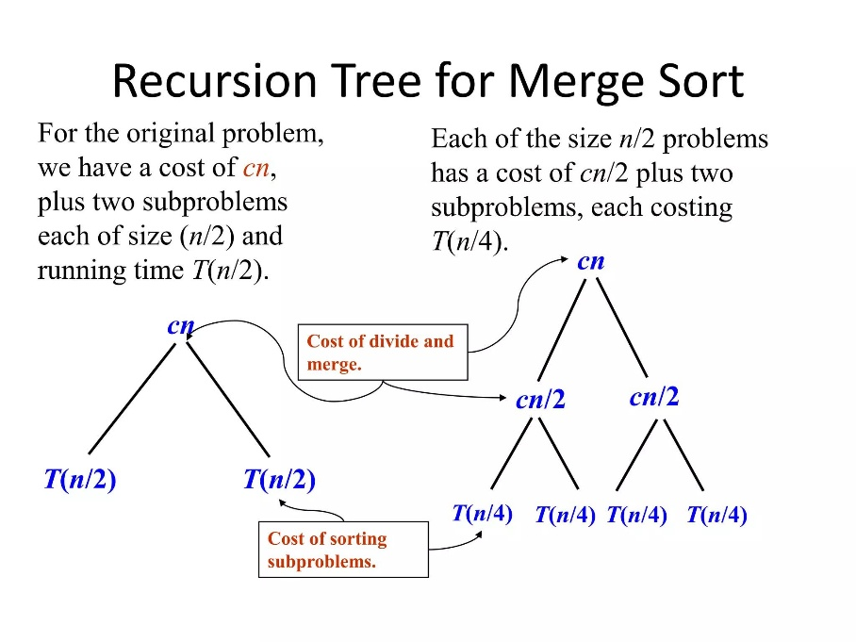
(e) Analyse Best, Average and Worst Cases
S1 – Linear Search
Best Case: The required product is the first item. Comparisons = 1.
Average Case: The product exists and is equally likely to appear at any position. Comparisons = (n + 1)/2.
Worst Case: The product is last or absent. Comparisons = n.
Expected Comparisons for Linear Search
Let p represent the probability that the product exists.
Expected comparisons:
E[C] = p(n + 1)/2 + (1 − p)n
Given n = 1,000,000 and p = 0.5,
E[C] = 0.5 × 1,000,001/2 + 0.5 × 1,000,000
E[C] = 250,000.25 + 500,000
E[C] = 750,000.25 comparisons.
Therefore, the expected number of comparisons is approximately 750,000.
S2 – Binary Search
Best Case: The target matches the middle element. Comparisons = 1.
Average Case: The target is found after a logarithmic number of comparisons.
Worst Case: The target is at the deepest search level or is absent. Comparisons = O(log n).
For a catalogue containing 1,000,000 elements, a standard binary search requires at most 20 comparisons.
Conclusion: Binary search is more efficient than linear search for a sorted catalogue. However, maintaining the sorted index requires additional work.
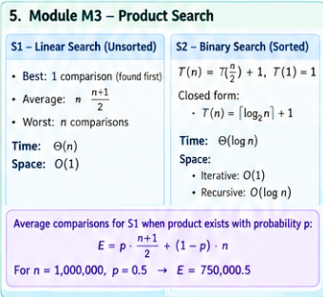
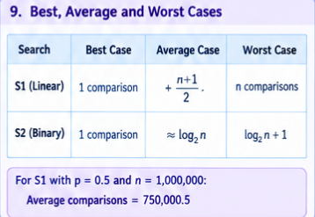
(f) Prove an Asymptotic Bound
Given,
f(n) = 3n² + 10n log₂ n + 50.
We need to prove that f(n) = Θ(n²) and f(n) is not O(n).
Proof of Θ(n²)
By the definition of Theta notation, positive constants c₁, c₂ and n₀ must exist such that:
0 ≤ c₁n² ≤ f(n) ≤ c₂n² for all n ≥ n₀.
Lower Bound:
f(n) = 3n² + 10n log₂ n + 50
Since the remaining terms are non-negative for n ≥ 1,
f(n) ≥ 3n².
Choose c₁ = 3.
Upper Bound:
For n ≥ 1, log₂ n ≤ n and 1 ≤ n².
Therefore,
10n log₂ n ≤ 10n²
and
50 ≤ 50n².
Hence,
f(n) ≤ 3n² + 10n² + 50n²
f(n) ≤ 63n².
Choose c₂ = 63 and n₀ = 1.
Thus,
3n² ≤ f(n) ≤ 63n² for all n ≥ 1.
Therefore,
f(n) = Θ(n²).
Proof that f(n) is Not O(n)
Assume f(n) = O(n). Then a positive constant c must exist such that f(n) ≤ cn for all sufficiently large n.
However,
f(n) ≥ 3n².
Therefore,
3n² ≤ cn.
Dividing both sides by n,
3n ≤ c.
This inequality cannot hold for all sufficiently large n because n increases without bound while c remains constant.
Hence,
f(n) is not O(n).
Conclusion: The report generator has quadratic time complexity, Θ(n²), and is not a linear-time algorithm.
(g) Scalability Decision
The server executes 10 basic operations per second. The nightly processing window is 10 minutes.
Available processing capacity:
10 × 10 × 60 = 6,000 basic operations.
The following estimates show the approximate workload at n = 1,000,000.
Module | Estimated Operations | Decision
M1 – Duplicate Detector | 499,999,500,000 comparisons | Redesign
M2 – API Rate Limiter | 524,287 audit operations | Optimize or increase capacity
M3 S2 – Binary Search | At most 20 comparisons | Suitable for individual searches
M4 – Current Design | Quadratic growth | Redesign
M4 – Proposed Design | n log₂ n growth | Improved, but more capacity is required
M5 – Sales Analytics | n log²₂ n growth | Optimize
Nightly Report Generator | Quadratic growth | Redesign
The estimated time for M1 alone is:
499,999,500,000 / 10 seconds
This is approximately 1,585 years.
For M2, the exact operation count at n = 1,000,000 is:
A(n) = 2¹⁹ − 1 = 524,287 operations.
Estimated time = 524,287 / 10 = 52,428.7 seconds, or approximately 14.6 hours.
Both modules exceed the 10-minute processing window under the given server assumption.
Recommendations
- Replace pairwise duplicate detection with hash-based detection.
- Remove unnecessary replication in the recommendation engine.
- Use indexed searching for product lookups.
- Optimize sales analytics and avoid repeated computations.
- Use incremental reporting and background processing where appropriate.
- Increase computing capacity and validate actual runtime through benchmarking.
Final Decision: Shop Sphere should prioritize M1, M4, M5 and the nightly report generator for redesign. M2 also needs capacity optimization to meet the specified deadline. S2 is efficient for individual searches, but its total workload depends on how many searches are performed.
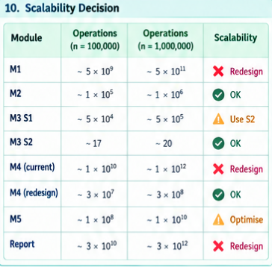
Innovative Enhancements and Future Scope
1. Smart Duplicate Detection Using Hashing
A composite key consisting of the normalized product title and seller ID can be used to detect duplicate listings efficiently. Under suitable hashing assumptions, expected processing time can be reduced from Θ(n²) to O(n).
2. Intelligent Resource Allocation
The platform can monitor request volume, execution time and memory consumption to allocate resources when demand increases. This can improve service availability during peak shopping periods.
3. Incremental Sales Analytics
Instead of recalculating every report from the beginning, the platform can update selected summaries using only new or changed transactions. This can reduce repeated work when the required statistics support incremental updates.
4. Parallel Processing
Independent analytics tasks can be distributed among multiple workers. The platform must also control synchronization overhead, data transfer and duplicated computation.
5. Deadline-Aware Job Scheduling
The platform can prioritize essential jobs and schedule non-urgent reports separately. Runtime estimates can be used to identify jobs that are likely to exceed the nightly processing window.
6. Performance Monitoring Dashboard
A monitoring dashboard can display execution time, number of processed products, memory usage and deadline status. This helps engineers identify bottlenecks before they affect customers.
These enhancements combine algorithm optimization with practical software engineering techniques to support future catalogue growth.

Conclusion
The scalability audit of Shop Sphere demonstrates that algorithm efficiency is essential for handling a growing e-commerce catalogue. The analysis identifies quadratic-time algorithms as major performance bottlenecks and shows how binary search, hashing and the removal of replicated computation can improve efficiency.
The proposed enhancements include incremental analytics, parallel processing, resource monitoring and deadline-aware job scheduling. However, algorithmic improvements alone do not guarantee that every task will finish within the 10-minute processing window. The platform must also validate performance using appropriate computing resources and real execution measurements.
By combining efficient algorithms with continuous performance monitoring, Shop Sphere can improve processing efficiency, reduce unnecessary computation and prepare for future growth.

